Student Name: Yuyang Gong Student Number: 49079984 Team Name: FriendZone
Week: 7
Title: Focusing on Conversation Prompts

Description:
We refined conversation prompts so that they could support users before and during a meeting without keeping attention on the screen. Prompts became more gradual as users spent time in a circle, moving from simple shared-interest questions toward more personal conversation only when familiarity had developed.
This interaction responded directly to the interview finding that people often need a reason to speak. It also supported the idea of putting phones down once the conversation begins. The phone prepares the encounter, but the value of the experience comes from reciprocal, face-to-face interaction.
Visual Evidence:
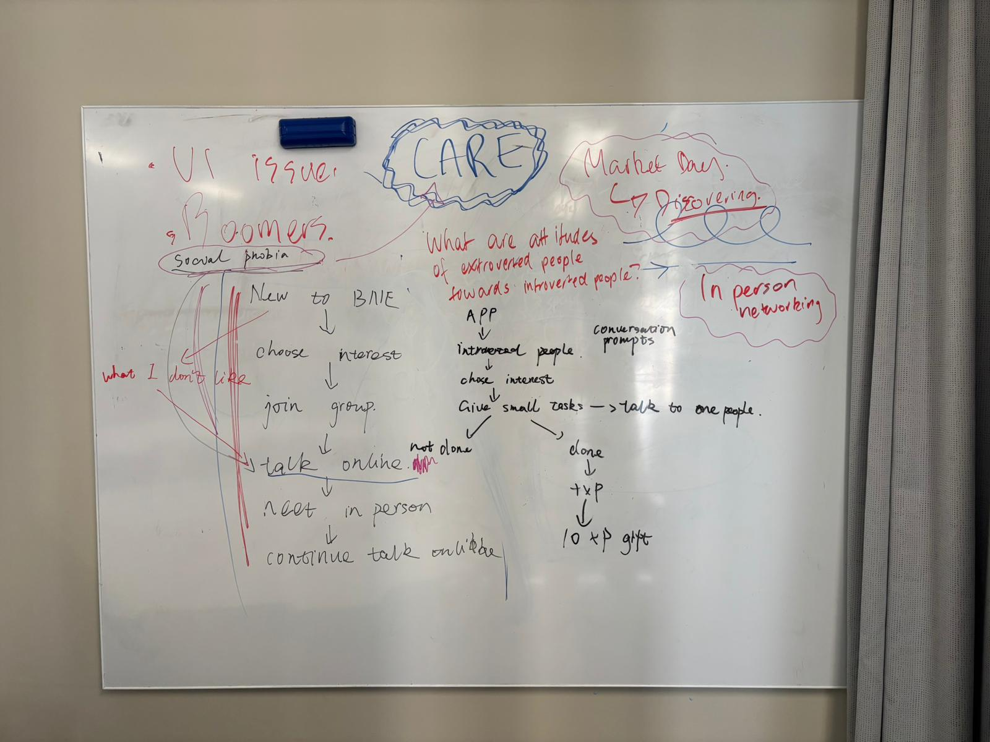
Tutorial exploration of care, comfort and low-pressure interaction principles.
Statement on Learning:
I learned that a small interaction can express the whole design position more clearly than a long feature list. Prompt timing, wording and the option to skip are important because a helpful suggestion can quickly become artificial or intrusive. The design must support conversation without scripting friendship.

